01 .Area chart:
- Connect the data and open a new worksheet.
2 .Drag Order Date to the Columns shelf and set it to Month.
3.Drag Quantity to the Rows shelf.
4.In the Marks card, change the chart type to Area.
5.Drag Ship Mode to Color to create stacked areas by shipping category.
6.Format the chart (title, colors, labels) and rename it “Area Chart.”

Output:
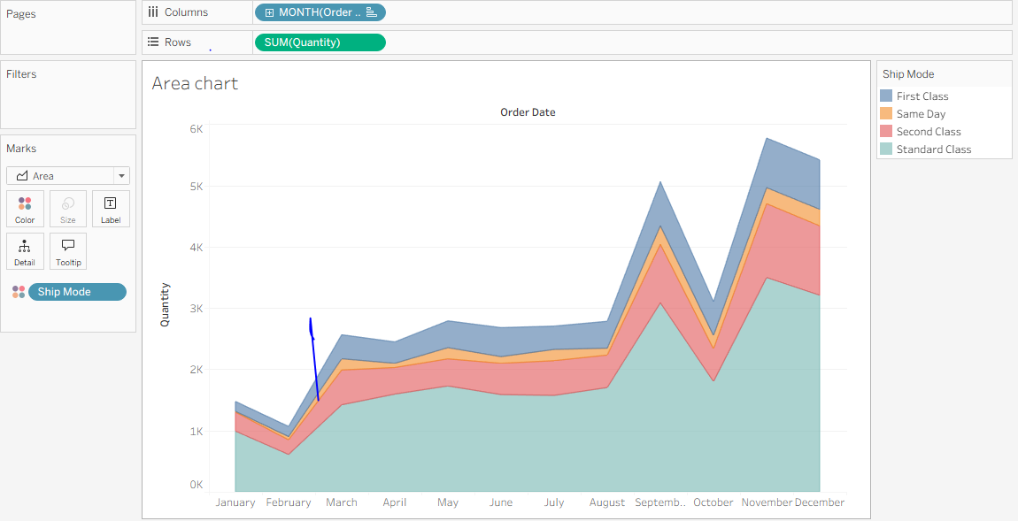

02.Bar Chart:
1.Connect the dataset and open a new worksheet.
2.Drag Region to the Rows shelf.
3.Drag Sales to the Rows shelf (next to Region).
4.Set the Marks type to Bar.
5.Drag Ship Mode to Color on the Marks card.
6.Drag Region to Filters and select West.
7.Format the chart and add the title "Bar Chart – Sales by Ship Mode (West Region)".
Output:

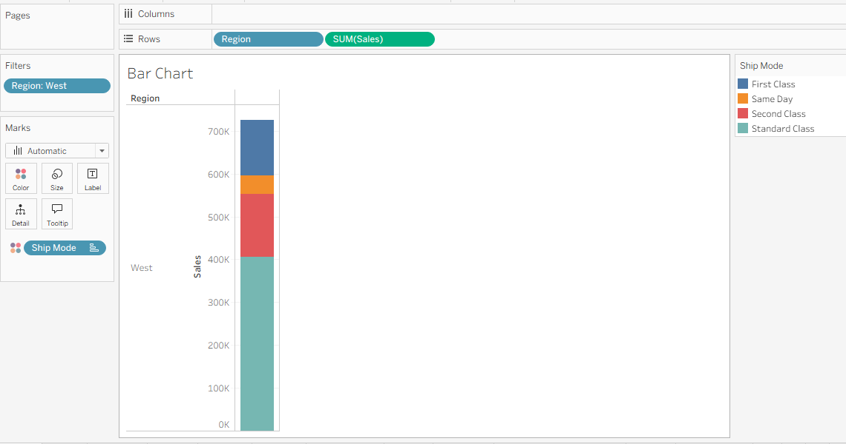

03.Box Plot:
1.Connect the dataset and open a new worksheet.
2.Drag Discount to the Columns shelf.
3.Drag Segment to the Rows shelf.
4.Drag Region next to Segment on the Rows shelf.
5.Open Show Me and select Box-and-Whisker Plot.
6.Keep Marks as Automatic/Circle and adjust formatting if needed.
7.Add the title "Box Plot of Discount by Segment and Region".
Output:
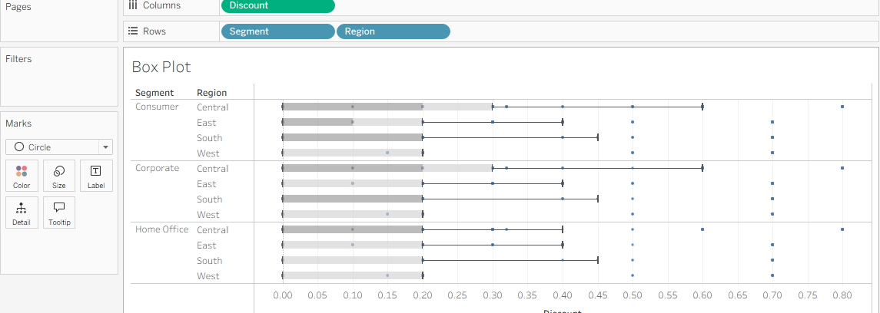

04.Gantt Chart:
1.Connect the dataset and open a new worksheet.
2.Drag Order Date (Week) to the Columns shelf.
3.Drag Sub-Category and Ship Mode to the Rows shelf.
4.Change the Marks type to Gantt Bar.
5.Drag AVG(Order Until Ship) to Size and Sub-Category to Color.
6.Format the chart and add the title "Gantt Chart – Shipping Duration by Sub-Category and Ship Mode".

Output:
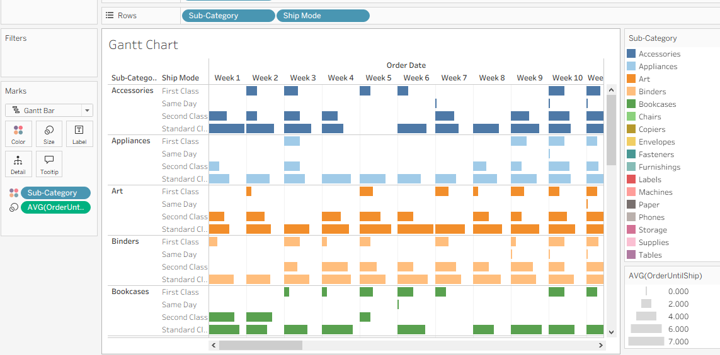

05.Heat Map:
1.Connect the dataset and open a new worksheet.
2.Drag Segment to the Columns shelf.
3.Drag Region and Sub-Category to the Rows shelf.
4.Change the Marks type to Square.
5.Drag Profit to Color and Sales to Size.
6.Format the colors, sizes, and title the chart "Heat Map – Sales and Profit by Segment, Region, and Sub-Category".

Output:
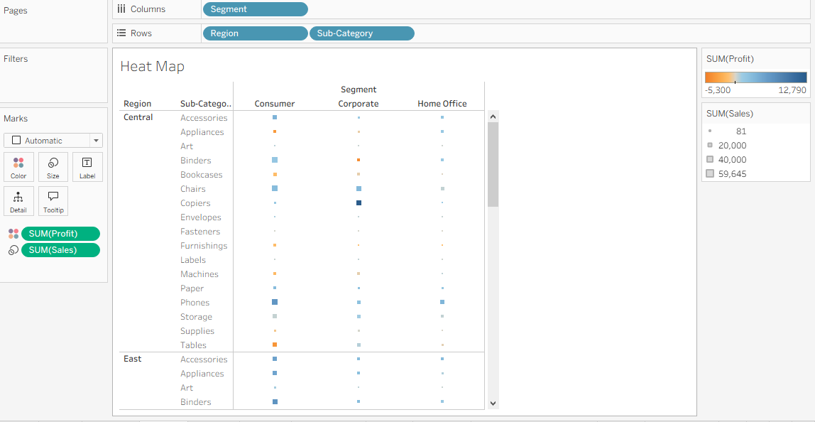

06.Histogram:
1.Create a Bin for the Quantity field and drag Quantity (bin) to the Columns shelf.
2.Drag CNT(Quantity) to the Rows shelf.
3.Set the Marks type to Bar.
4.Drag Segment to Color to compare segments.
5.Format the chart and add the title "Histogram of Quantity by Segment".
Output:
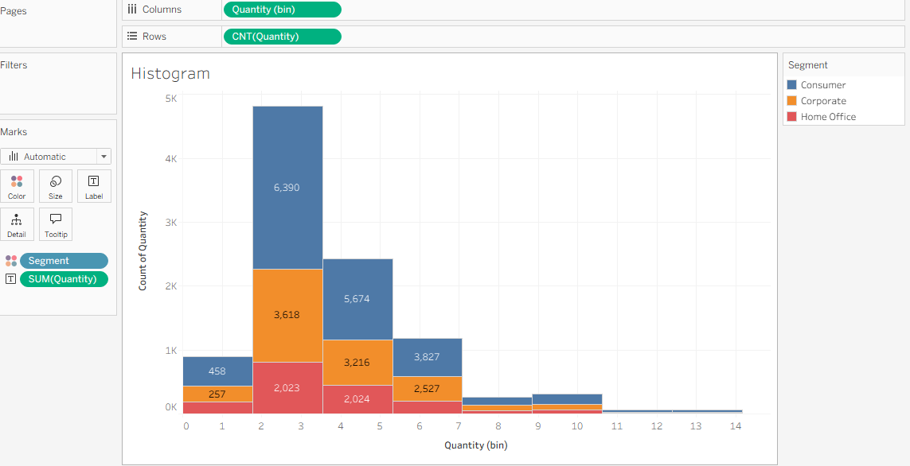

07.Line chart:
1.Drag MONTH(Ship Date) to the Columns shelf.
2.Drag Measure Values to the Rows shelf.
3.Keep only Sales and Profit in Measure Values.
4.Drag Measure Names to Color and set the Marks type to Line.
5.Add Forecast (optional), format the chart, and title it "Sales and Profit Trend by Ship Date".

Output:
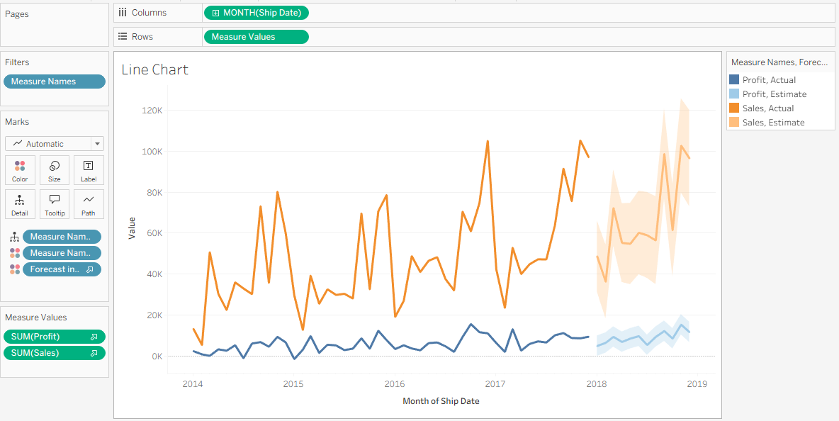

08.Packed Bubbles:
1.Open a new worksheet and select Show Me → Packed Bubbles.
2.Drag Category and Region to Label.
3.Drag Sales to Size.
4.Drag Profit to Color.
5.Adjust bubble size, colors, and labels for clarity.
6.Add the title "Packed Bubbles – Sales and Profit by Category and Region".
Output:
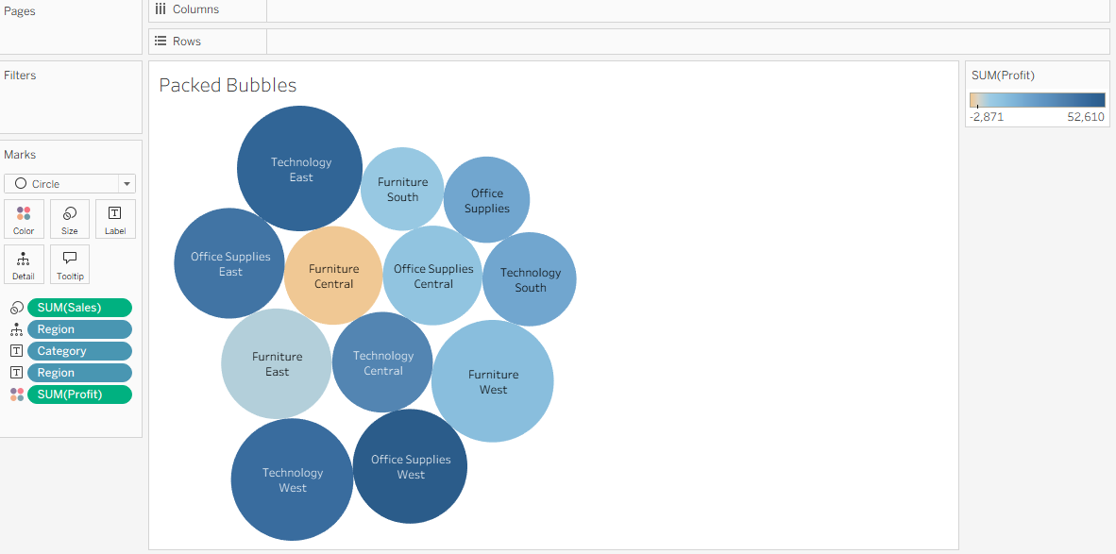

09.Pie chart:
1.Drag Category to Color.
2.Drag Profit to Angle.
3.Drag Profit to Size and increase the pie size.
4.Drag Category to Label.
5.Edit the title and format colors/labels as needed.

Output :
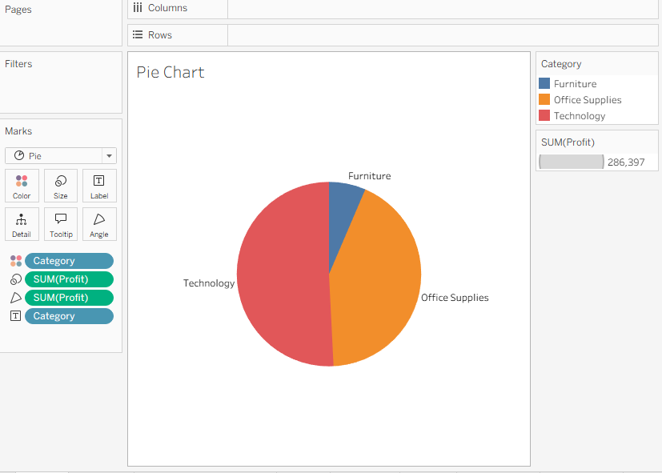

10.Scatter Plot:
1.Drag Sales to the Columns shelf.
2.Drag Profit to the Rows shelf.
3.Set Marks type to Circle (or Automatic).
4.Drag Category to Color.
5.Drag Region to Detail.
6.Open the Analytics pane and drag Trend Line onto the view (Per Color).
7.Format the chart and rename the title to Scatter Plot.

Output :
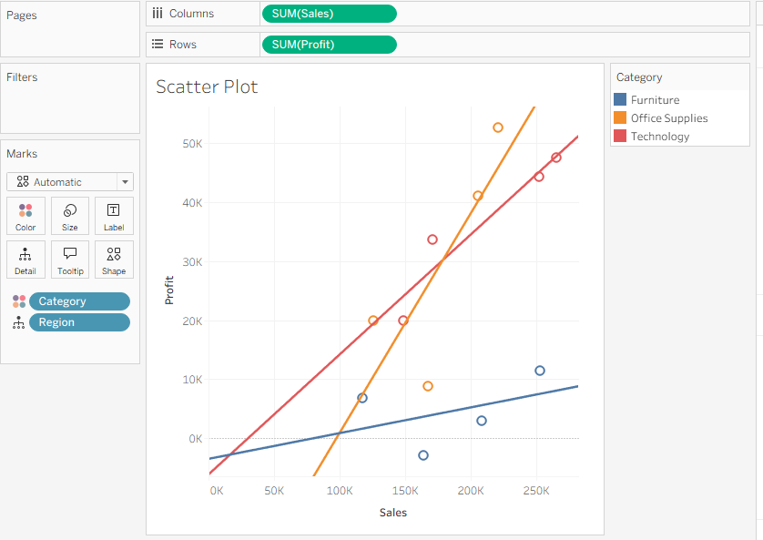

11.Text table with percentages:
1.Open a new worksheet.
2.Drag YEAR(Order Date) to the Columns shelf.
3.Drag Region and Sub-Category to the Rows shelf.
4.Drag Sales to the Text mark on the Marks card.
5.Right-click SUM(Sales) → Quick Table Calculation → Percent of Total.
6.Set Compute Using to Table (Down) or as required.
7.Format the values as Percentage and rename the title to Text Table With Percentages.

Output :
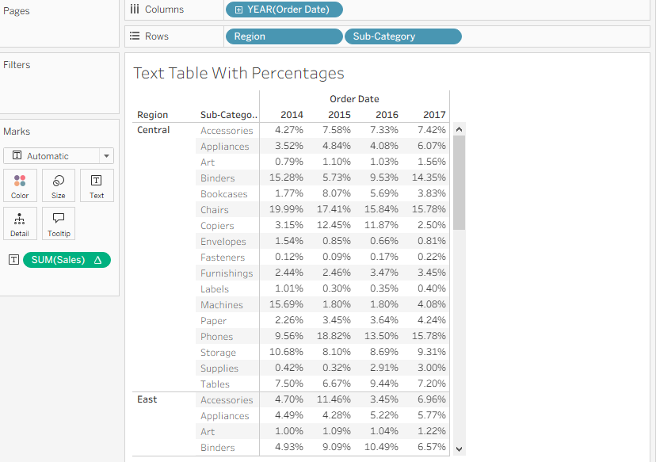

12.Tree map :
1.Open a new worksheet.
2.Select Show Me → Treemap.
3.Drag Sub-Category to Label.
4.Drag Sales to Size.
5.Drag Profit to Color.
6.Adjust labels and color scale for better visibility.
7.Rename the worksheet title to Tree Map.

Output :
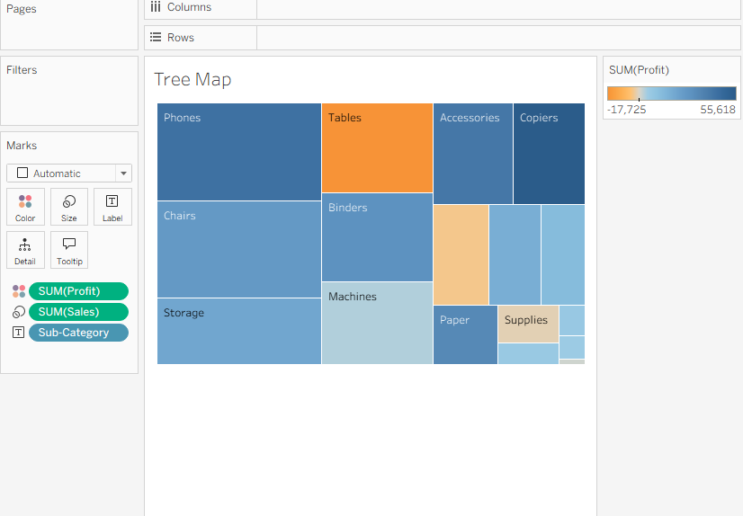

13.Dount chart:
1.Create a calculated field Zero = 0.
2.Drag SUM(Zero) to the Rows shelf twice.
3.Right-click the second SUM(Zero) and select Dual Axis.
4.Set both Marks cards to Pie.
5.On the first Pie, drag Region to Color and Sales to Angle/Label.
6.On the second Pie, reduce Size and set a white color to create the donut hole; add the center label (e.g., Total Sales).
7.Format the chart and rename the title to Donut Chart.
.
Output :
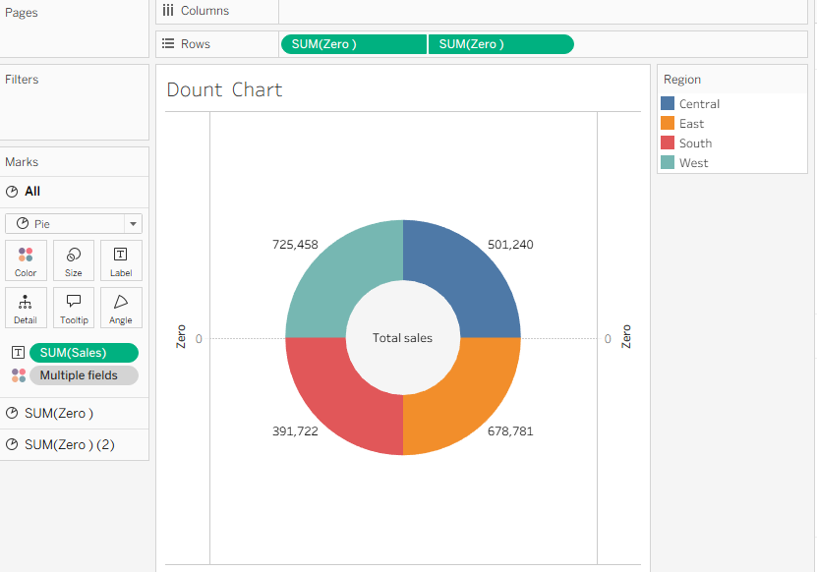

14.Map chart:
1.Open a new worksheet.
2.Double-click State to generate the map.
3.Tableau automatically adds Longitude (generated) to Columns and Latitude (generated) to Rows.
4.Set the Marks type to Map (or Filled Map).
5.Drag State to Detail.
6.Drag State to Label (optional, to display state names).
7.Drag Sales to Color.
8.Drag Profit to Tooltip.
9.Drag Region to the Filters shelf and select the required regions.
10.Format the color scale and rename the worksheet title to Map Chart.
Output :
